GMAS Meeting Resources

NO Retakes this year…
http://www.gaexperienceonline.com/ : parents to assess the Georgia Milestones practice tests for practice
http://www.gaexperienceonline.com/

· Click Test Practice
· Online Training Tools
· EOG Test Practice, Standard Online Tools
· Grades 3-5
· Type Username & password that is on screen, click sign in
· Click Continue
· Grades 3-5 Test Practice
· Follow prompts

- GMAS Assessment Guide
https://www.gadoe.org/Curriculum-Instruction-and-Assessment/Assessment/Pages/Georgia-Milestones-End-of-Grade-Assessment-Guides.aspx
- Reading & Evidence Based Writing Sampler (Item Scoring Sampler)
https://www.gadoe.org/Curriculum-Instruction-and-Assessment/Assessment/Pages/Item-Samplers.aspx

GMAS Weights
https://www.gadoe.org/Curriculum-Instruction-and-Assessment/Assessment/Documents/Milestones/Blueprints/GA_EOG_Grade_3_Blueprint_July_2020.pdf 3rd grade
https://www.gadoe.org/Curriculum-Instruction-and-Assessment/Assessment/Documents/Milestones/Blueprints/GA_EOG_Grade_4_Blueprint_July_2020.pdf 4th grade
https://www.gadoe.org/Curriculum-Instruction-and-Assessment/Assessment/Documents/Milestones/Blueprints/GA_EOG_Grade_5_Blueprint_July_2020.pdf 5th grade

Free Online GMAS Practice Tests and Tips for Georgia Milestones Success | Edulastic
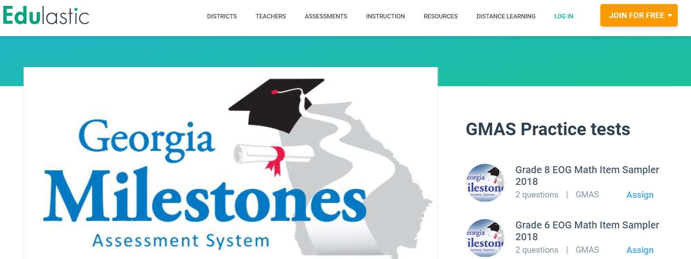

GMAS Practice Tests and Sample Questions | GMAS Test (lumoslearning.com)
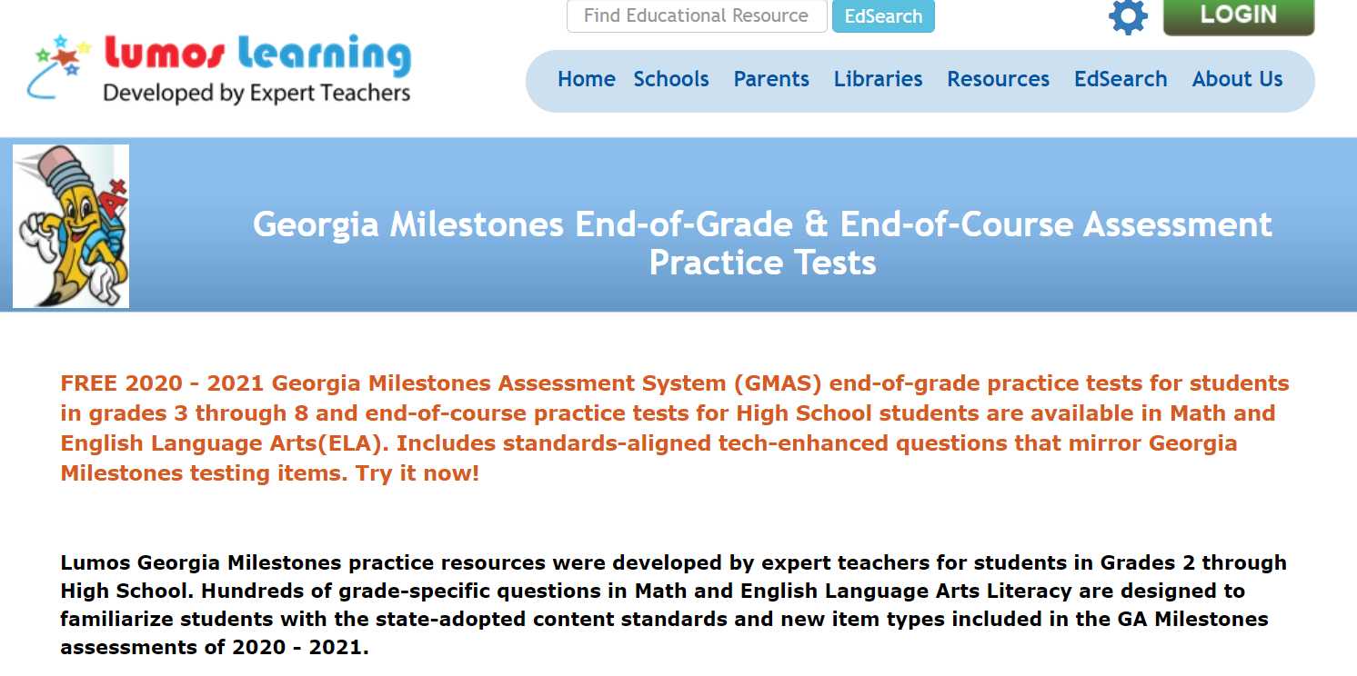

GaDOE Assessment Div Writing PL : GMAS Writing
