Feedback  The Parent and Family Engagement Policy is developed through a partnership with parents, staff, student and community input. All Stakeholders at Dimon Magnet Academy are invited to give suggestions, comments, and feedback. For any part of the Parent and Family Engagement Policy/ School-Parent Compact that you feel is not satisfactory with the students’ and the school’s goals for academic achievement, please provide suggestions and feedback. Please send those suggestions and/or feedback to the school office and/or Parent Contact Representative.  Thank you for your continued support!  Please scan the QR code to provide feedback or email davis.gena.m@muscogee.k12.ga.us.  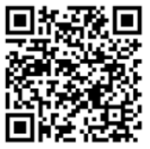 |  |  | Visit Our Parent Resource Center/Area  Our Parent Resource Center/Area has learning games, books, workbooks, and many other resources available for families to check out or keep for use at home. Please contact Gena Davis at the school for help finding resources, navigating the Parent Portal, connecting with teachers, and learning about ways you can help your children at home.  School Phone Number: (706) 683-8772  Website: http://www.dimonmagnetacademy.com/  Muscogee County School District Mission  Our mission is to inspire and equip all students to achieve unlimited potential.  Muscogee County School District Vision  MCSD is a beacon of educational excellence where all are known, valued, and inspired.   |  |  |   Parent and Family Engagement Policy & School-Parent Compact 2026-2027  Revised: August 3, 2026  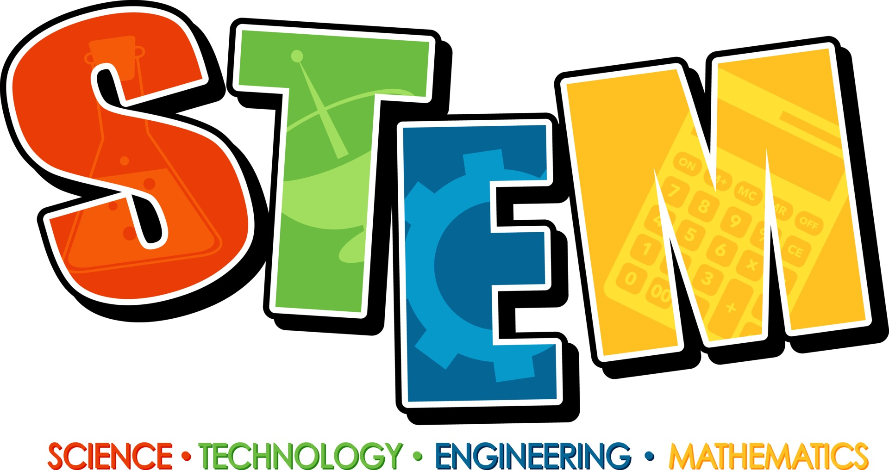  Principal, Mrs. Emily Wilson  Assistant Principal, Mr. Michael Collier  480 Dogwood Dr.  Columbus, GA 31907  706-683-8772  http://www.dimonmagnetacademy.com/

Our School Goals  Dimon Magnet Academy will provide all students with a high-quality curriculum and instruction in a supportive and effective learning environment to meet high academic standards.  School’s SMART Goals:  Smart Goal 1: By May 2029, 85% of instructional staff and 60% of additional stakeholders will be trained and coached on positive and healthy behavioral and academic norms to continuously foster an engaging learning environment that minimizes distractions, strengthens the schoolwide SEL system, and promotes collaboration between home and school in support of the whole child as evidenced by behavioral/academic data, surveys, training and communication logs, and walk throughs.  Smart Goal 2: By May 2029, 85% of instructional staff will be trained to effectively utilize formative, summative, and diagnostic data to drive instructional decisions and employ high-quality standards-based Tier I instruction with appropriate scaffolds and rigor that promotes student voice and agency as measured by walkthroughs, training logs, lesson plans, surveys, and assessment data.  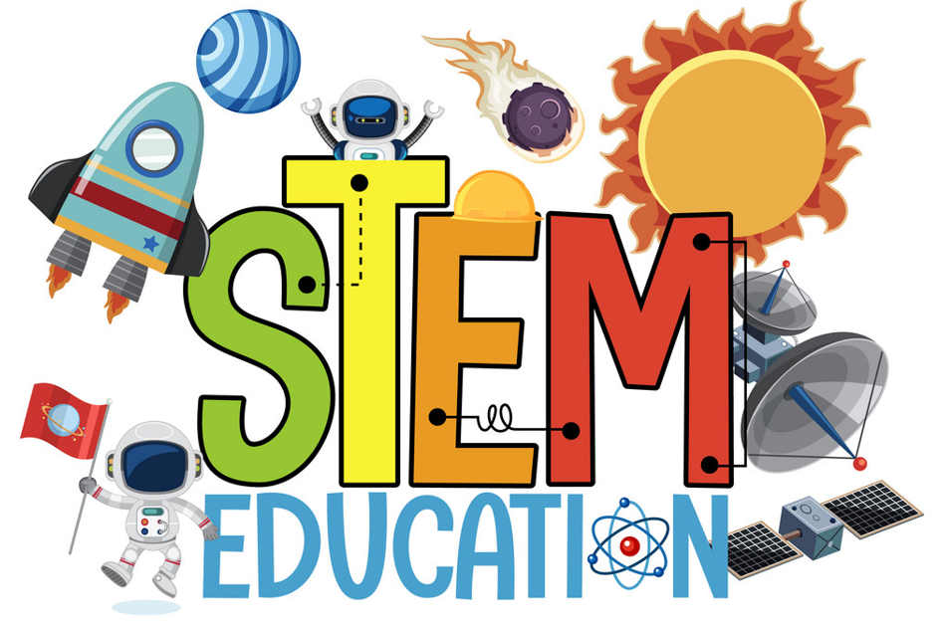 |  |  | Working Together To Ensure Success  Dimon Magnet Academy Elementary School will…  Teachers are expected to work with students and their families to support student success in all core subject areas and STEM learning opportunities. Some of our key connections with families will be:  - Coordinate activities for Parent and Family Engagement Workshops and share strategies with families on how to help students at home.  - Increase opportunities for parents to become involved in promoting student success.  - Establish open lines of communication with parents concerning their child’s school performance.  - Provide personalized learning experiences for every student.  Mrs. Emily Wilson, Principal  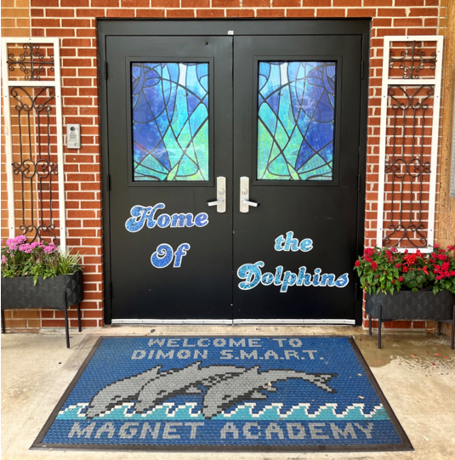 |  |  | As Students, we will…  Students are encouraged to participate in the educational process. A successful student takes ownership of his/her learning and sets high educational goals.  - Work hard to increase Lexile Reading Levels.  - Work cooperatively with my teachers to increase academic success.  - Work hard to get and maintain good grades.  - Fully engage in STEAM learning opportunities throughout the school.  As Families, we will…  Parents are expected to participate in the education of their children. Without the cooperation and partnership between parents and school staff, we cannot effectively help a student reach his or her full potential. The major role of parents is to continually show the child that they are interested and supportive of how their child is doing in school.  - Use reading materials the teacher sends home each week to help my child gain knowledge in Reading.  - Help my child increase their reading comprehension skills.  - Communicate with my child’s teacher regarding any questions or concerns about my child’s individual goals for learning.  - Attend Parent and Family Engagement Workshops.

Our District Goals  - By June 2031, Muscogee County School District will increase the percentage of students performing at or above grade-level readiness by 20 percentage points through the implementation of evidence-based instructional practices, targeted interventions, and ongoing progress monitoring across all schools.  - By June 2031, Muscogee County School District will reduce districtwide chronic absenteeism by a minimum of 20% from the established baseline year (2025–2026), as measured by official student attendance data reported through the state accountability system.  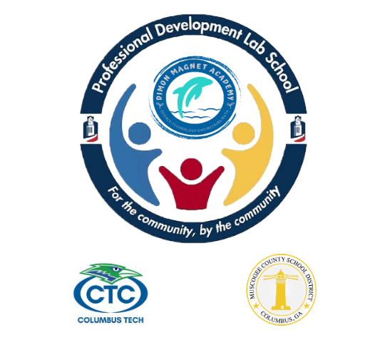   |  |  | ENGAGING AND EMPOWERING FAMILIES WITH…  School Measures to Provide Required Assistance: Dimon Magnet Academy will take the following measures to promote and support parents:  Curriculum Information: Inform parents throughout the year about what their child is learning by providing parent and family engagement meetings and workshops, parent-teacher conferences, and information on Canvas, and on our school website.  Student Progress Monitoring: Ensure families are familiar with the online resource Infinite Campus (Parent Portal) which allows families to view grades, attendance, schedules, assessments, course history, and much more. Monitoring student progress in school is an important way to be involved in their education.  Parent Resources: Create and maintain a Parent Resource Area/Room to allow parents opportunities to check out materials to assist them with helping their child at home. Resources are available in English and Spanish.  Staff Training: Conduct staff development on parent engagement practices and effective strategies for staff to communicate and build partnerships with parents.  Communication: Ensure schools publish all information related to school workshops, programs, meetings, etc and communicate on a regular basis.  Transition Support: Partner with early childhood programs, elementary schools, middle schools, high schools, college and career organizations, parent resource centers, or other programs (as applicable) to help prepare families and their children for successful school transition. |  | Communication | Dimon Magnet Academy is committed to keeping open lines of communication with families. We have several ways to communicate. We utilize two-way communication through the school website, email, phone calls, parent conferences, social media, Infinite Campus, and Canvas to reach our students and families.  Dimon Magnet Academy will also provide materials at conferences and workshops to help parents work with their children at home. Parents can request additional conferences by contacting the school or their child’s teacher. If you need interpretation and/or translation services, please contact the school at (706) 748-2723.  Some of the ways you can expect us to reach you are:  - Message XR phone calls and/or text messages  - Updates on the school’s website  - Facebook, Instagram  - Parent Emails  - Parent-teacher conferences  - Canvas  - Class Dojo  
Each Title I school will conduct a yearly annual meeting to review and revise the Parent and Family Engagement Policy and School-Parent Compact. Each school will invite all families to provide input on revisions to the policy/compact. Families are welcome to provide input throughout the year via feedback forms, emails, comments, or telephone. The revised policy/compact will be available throughout the year in our parent resource area and on our school website.  Where is the Parent and Family Engagement Policy and School-Compact available and who is it for?    The Family Engagement Policy/School-Parent Compact and all other Title I information is designated for all families and is available on our school’s website under the Parent Section. Families can also find paper copies of the Parent and Family Engagement Policy/School-Parent Compact in our Parent Center/Area and at Parent and Family Engagement meetings. All families at Dimon Magnet Academy are encouraged and invited to fully participate in the opportunities as described in our Parent and Family Engagement Policy/School-Parent Compact. Dimon Magnet Academy will provide full opportunities for the participation of families with limited English, parents with disabilities, and parents of migratory children. |  |  | The Parent and Family Engagement Policy describes how Dimon Magnet Academy School will provide opportunities to improve parent and family engagement to support student learning. Dimon Magnet Academy values the contributions and involvement of families in order to establish partnerships for the common goal of improving student achievement. The Parent and Family Engagement Policy describes the different ways the school will support parent and family engagement and how families are encouraged to be full partners in the decision-making of their child’s education.  What is a School-Parent Compact?  The School-Parent Compact is a written agreement that outlines how our school, our students, and our families will work together to ensure the academic success of all students. An effective School-Parent Compact contains the following elements:  - Jointly developed by families, school staff, students, community business partners, and other stakeholders during our annual review meeting  - Clear learning goals that are linked to the school’s improvement plan  - Specific skills students will learn during the year  - Strategies that staff, families, and students will use to improve student learning  - Ways to extend learning at home  - Methods teachers and family members will use to communicate about student progress  - Opportunities for family members to observe and participate in the classroom  - Review and revise the School-Parent Compact at meetings and provide workshops throughout the year to assure we are diligent in our efforts to support academic success for all students. |  |  | What is Title I?  Dimon Magnet Academy is identified as a Title I school as part of the Every Student Succeeds Act (ESSA). Title I is a federal grant that was designed to ensure that all children receive a high-quality education and reach grade-level proficiency. Title I programs must be based on effective means of improving student achievement and include strategies to support parent and family engagement. Parents and family members of children receiving services shall be involved in the decisions regarding how funds reserved are allotted for parent and family engagement activities and resources.  Building Partnerships  Dimon Magnet Academy collaborates with families and community partners to provide multiple workshops and trainings at various times that meet the needs of the parents and support Parent and Family Engagement at the school. We will offer the following activities to build our partnership with families:  - Annual Title I Parent Meeting - To inform parents of the requirements of Title I and the school’s participation as well as the parents’ rights under Title I.  - Parent and Family Engagement/School-Parent Compact Review Meeting  - Literacy and Technology Meeting  - Georgia Milestones Meeting  - Transition Meetings  - Additional Activities To Build Parent Capacity  Please visit our website regularly and check emails/notifications to learn about dates, times, and other details about upcoming events.  http://www.dimonmagnetacademy.com/
What is a Parent and Family Engagement Policy?
How is the Parent and Family Engagement Policy and School-Compact developed and revised?

