Feedback  How is the Parent and Family Engagement Policy and School-Compact developed and revised?  All Stakeholders at Dimon Magnet Academy are invited to give suggestions, comments, and feedback. For any part of the Parent and Family Engagement Policy/ School-Parent Compact, that you feel is not satisfactory with the students’ and the school’s goals for academic achievement, please provide suggestions and feedback. Please send those suggestions and/or feedback to the school office and/or Parent Contact Representative.  Thank you for your continued support!  Please scan the QR code to provide feedback.   |  |  | Visit Our Parent Resource Center/Area  Our Parent Resource Center/Area has learning games, books, workbooks, and many other resources available for families to checkout or keep for use at home. Please contact the school for help finding resources, navigating the Parent Portal, connecting with teachers, and learning about ways you can help your children at home.  School Phone Number: (706) 683-8772  Website: http://www.dimonmagnetacademy.com/  Muscogee County School District Mission  Our mission is to inspire and equip all students to achieve unlimited potential.  Muscogee County School District Vision  MCSD is a beacon of educational excellence where all are known, valued, and inspired.   |  |  | 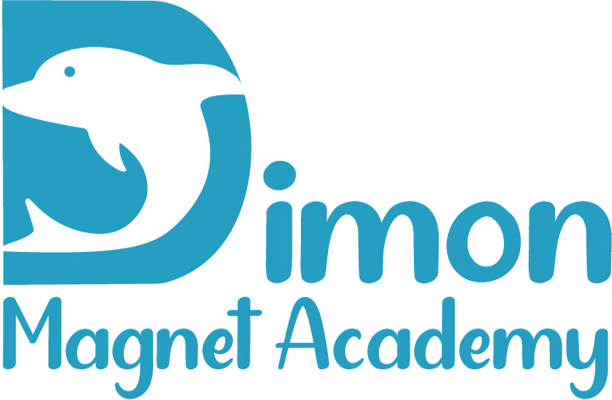  Parent and Family Engagement Policy & School-Parent Compact 2023-2024  Revised: August 3, 2023  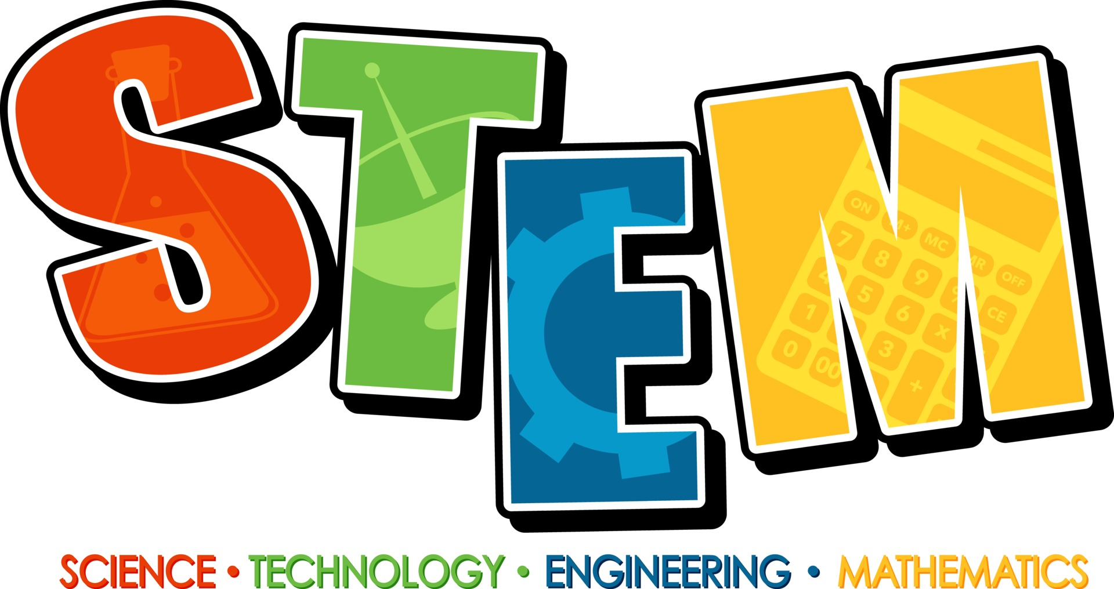  Principal, Mrs. Emily Wilson  Assistant Principal, Mr. Michael Collier  480 Dogwood Dr.  Columbus, GA 31907  706-683-8772  http://www.dimonmagnetacademy.com/

Our School Goals  Dimon Magnet Academy will provide all students with high quality curriculum and instruction in a supportive and effective learning environment to meet high academic standards.  School’s SMART Goals:  Smart Goal 1: By May 2024, 85% of teachers, support teachers, and staff will be trained and effectively implementing content-based critical thinking strategies that promote communication of student thinking and transfer of knowledge into practical thinking to increase instructional excellence as measured by lesson plans, activity agendas, data sheets, and walkthroughs.  Smart Goal 2: By May 2024, 80% of Dimon teachers will be trained and coached on three key areas (Parent Engagement, Social Emotional Learning Strategies, and Tier II & Tier III Interventions) of the MTSS Process and will implement with consistency and fidelity as evidenced by classroom walkthroughs, schoolwide discipline procedures, sign-in sheets, parent surveys, agendas, and use of school-wide communication systems.  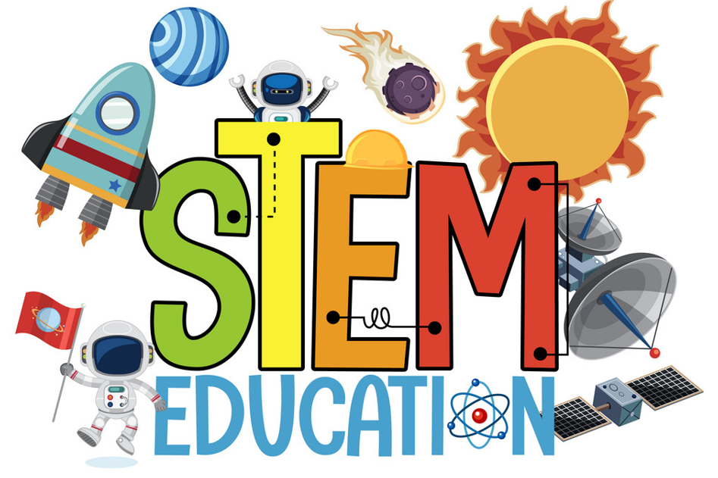 |  |  | Working Together To Ensure Success  Dimon Magnet Academy Elementary School will…  Teachers are expected to work with students and their families to support students’ success in reading and math. Some of our key connections with families will be:  - Coordinate activities for Parent and Family Engagement Workshops and share strategies with families on how to help students at home.  - Increase opportunities for parents to become involved to promote student success.  - Establish open lines of communication with parents concerning their child’s school performance.  - Provide personalized learning experiences for every student.  .  Mrs. Emily Wilson, Principal  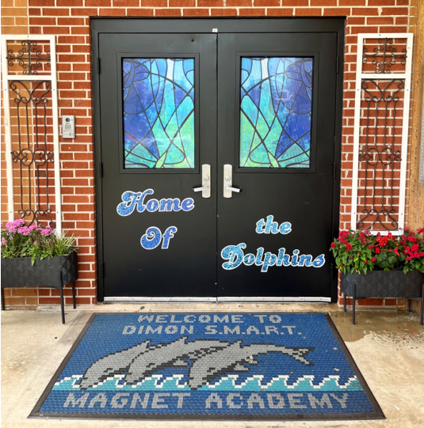 |  |  | As Students, we will…  Students are encouraged to participate in the educational process. A successful student takes ownership of his/her learning and sets high educational goals.  - Work hard to increase Lexile Reading Levels.  - Work cooperatively with my teachers to increase academic success.  - Work hard to get and maintain good grades.  - Work hard in Achieve 3000 and Lexia to expand my reading levels.  As Families, we will…  Parents are expected to participate in the education of their children. Without the cooperation and partnership between parents and school staff, we cannot effectively help a student reach his or her full potential. The major role of parents is to continually show the child that they are interested and supportive of how their child is doing in school.  - Use reading materials the teacher sends home each week to help my child gain knowledge in Reading.  - Help my child increase their reading comprehension skills.  - Communicate with my child’s teacher regarding any questions or concerns about my child’s individual goals for learning.  - Attend Parent and Family Engagement Workshops.

Our District Goals  - By July 2026, MCSD will establish professional development to address individual student needs through clearly defined and communicated learning targets with success criteria for Tier I Instruction (to include Personalized Learning) measured by classroom observation and feedback cycles at an effectiveness level of 90%. MCSD will implement MTSS at a level 3 rating or higher as measured by the School GaTSS Fidelity of Implementation Rubric in 80% of MCSD schools.  - By July 2026, 80% of MCSD schools will implement data-based decision-making processes at a level 4 rating or higher as measured by the School GaTSS Fidelity of Implementation Rubric.  - By July 2026, MCSD will provide differentiated professional development for all employee groups, and 80% of all MCSD employees will engage in self-selected, differentiated professional development opportunities.  - By July 2026, MCSD will increase awareness of and adherence to the district’s Mission, Vision and Values to create a “Culture of Kindness” for all stakeholders as measured by stakeholder surveys and closing the gap result plan to reduce office discipline referrals, increase in percentage in attendance, increase wraparound services, and improve school climate. |  |  | ENGAGING AND EMPOWERING FAMILIES WITH…  School Measures to Provide Required Assistance: Dimon Magnet Academy will take the following measures to promote and support parents:  Curriculum Information: Inform parents throughout the year about what their child is learning by providing parent and family engagement meetings and workshops, parent-teacher conferences, information on Canvas, and on our school website.  Student Progress Monitoring: Ensure families are familiar with the online resource Infinite Campus (Parent Portal) that allows families to view grades, attendance, schedules, assessments, course history, and much more. Monitoring student progress in school is an important way to be involved in their education.  Parent Resources: Create and maintain a Parent Resource Area/Room to allow parents opportunities to checkout materials to assist them with helping their child at home. Resources are available in English and Spanish.  Staff Trainings: Conduct staff development quarterly on parent engagement practices and effective strategies for staff to communicate and build partnerships with parents.  Communication: Ensure schools publish all information related to school workshops, programs, meetings, and activities in both English and Spanish and communicated on a regular basis.  Transition Support: Partner with early childhood programs, elementary schools, middle schools, high schools, college and career organizations, parent resource centers, or other programs (as applicable) to help prepare families and their children for successful school transitioning. |  | Communication | Dimon Magnet Academy is committed to keeping open lines of communication with families. We have several ways to communicate. We utilize two-way communication through the school website, email, phone calls, parent conferences, social media, Infinite Campus and Canvas to reach our students and families.  Dimon Magnet Academy will also provide materials at conferences and workshops to help parents work with their children at home. Parents can request additional conferences by contacting the school or their child’s teacher. Transportation and childcare may also be offered for parents to prevent barriers to family engagement. For all students who reside in residential facilities served by the Muscogee County School District, family engagement correspondence and activities will be mailed to each facility where students reside. If you need interpretation and/or translation services, please contact the school at (706) 748-2723.  Some of the ways you can expect us to reach you are:  - Connect-Ed phone calls and/or text messages  - Updates on the school’s website  - Facebook, Twitter, Instagram  - Parent Emails  - Parent-teacher conferences  - Canvas    - Class Dojo
Each Title I school will conduct a yearly annual meeting to review and revise the Parent and Family Engagement Policy and School-Parent Compact. Each school will invite all families to provide input on revisions to the policy/compact. Families are welcome to provide input throughout the year via feedback forms, emails, comments, or telephone. The revised policy/compact will be available throughout the year in our parent resource area and on our school website.  Where is the Parent and Family Engagement Policy and School-Compact available and who is it for?    The Family Engagement Policy/School-Parent Compact and all other Title I information is designated for all families and is available on our school’s website under the Parent Section. Families can also find paper copies of the Parent and Family Engagement Policy/School-Parent Compact in our Parent Center/Area and at Parent and Family Engagement meetings. All families at Dimon Magnet Academy are encouraged and invited to fully participate in the opportunities as described in our Parent and Family Engagement Policy/School-Parent Compact. Dimon Magnet Academy will provide full opportunities for the participation of families with limited English, parents with disabilities, and parents of migratory children. |  |  | The Parent and Family Engagement Policy describes how Dimon Magnet Academy School will provide opportunities to improve parent and family engagement to support student learning. Dimon Magnet Academy values the contributions and involvement of families in order to establish partnership for the common goal of improving student achievement. The Parent and Family Engagement Policy describes the different ways the school will support parent and family engagement and how families are encouraged to be full partners in the decision-making of their child’s education.  What is a School-Parent Compact?  The School-Parent Compact is a written agreement that outlines how our school, our students, and our families will work together to ensure the academic success of all students. An effective School-Parent Compact contains the following elements:  - Jointly-developed by families, school staff, students, community business partners, and other stakeholders during our annual review meeting  - Clear learning goals that are linked to the school’s improvement plan  - Specific skills students will learn during the year  - Strategies that staff, families, and students will use to improve student learning  - Ways to extend learning at home  - Methods teachers and family members will use to communicate about student progress  - Opportunities for family members to observe and participate in the classroom  - Review and revise the School-Parent Compact at meetings and provide workshops throughout the year to assure we are diligent in our efforts to support academic success for all students. |  |  | What is Title I?  Dimon Magnet Academy is identified as a Title I school as part of the Every Student Succeeds Act (ESSA). Title I is a federal grant that was designed to ensure that all children receive a high quality education and reach grade level proficiency. Title I programs must be based on effective means of improving student achievement and include strategies to support parent and family engagement. Parents and family members of children receiving services shall be involved in the decisions regarding how funds reserved are allotted for parent and family engagement activities and resources.  Building Partnerships  Dimon Magnet Academy collaborates with families and community partners to provide multiple workshops and trainings at various times that meet the needs of the parents and support Parent and Family Engagement at the school. We will offer the following activities to build our partnership with families:  - Annual Title I Parent Meeting - To inform parents of the requirements of Title I and the school’s participation as well as the parents’ rights under Title I.  - Parent and Family Engagement/School-Parent Compact Review Meeting  - Literacy and Technology Meeting  - Georgia Milestones Meeting  - Transition Meetings  - Additional Activities To Build Parent Capacity  Please visit our website regularly and check emails/notifications to learn about dates, times and other details about upcoming events.  http://www.dimonmagnetacademy.com/
What is a Parent and Family Engagement Policy?
How is the Parent and Family Engagement Policy and School-Compact developed and revised?

