Uniforms/Dress Code
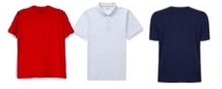
SHIRTS
- Uniform shirts are a SOLID buttoned down shirt with a collar
- Any color uniform shirt is acceptable
- No graphics allowed
- Logos/emblems may on be 1 inch
- Shirts may have short or long sleeves. No sleeveless shirts, tank tops, or spaghetti strap tops should be worn.
- White undershirts MAY NOT be worn as uniform shirts
- Midriffs should not be bare. Shirts must cover the midriff when the arms are raised.
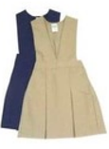
PANTS
- SOLID khaki or navy pants, shorts, skirts, or jumpers
- Shorts and skirts MUST be no higher than 3 inches above the knee
- Pants must be worn at the waist
- Pants and jeans may not have any rips, tears, or holes above the knee. Jeans may only be worn on Fridays or approved special events.
SHOES
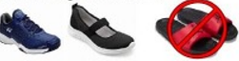
- Tennis shoes are preferred. However, students may wear other types of shoes. All shoes must be worn with a back, including Crocs. If students continuously wear inappropriate shoes, tennis shoes will be required.
HOODIES/JACKETS
- Hoodies are NOT allowed inside the school building for the 2023 – 2024 school year. Students wearing a hooded jacket to school must remove the jacket and place it in the backpack prior to entering the school building.
- Students are permitted to wear a light jacket without a hood or sweater inside the school and classrooms. Heavy, thick coats will be removed while inside the school building.
HATS
- Hats, gloves, and caps may not be worn in the building.
- No stockings, doo-rags, sweatbands, or bandanas.
- No animal ears or tails permitted. This includes headbands with horns, ears, or costume-like attire.

SMALL BACKPACKS/BAGS/PURSES
- Each student is permitted to bring one textbook sized backpack to school. No rolling backpacks allowed.
- No additional mini backpacks, fanny packs, or purses should be brought to school.
- If female students need personal hygiene products, then they will be permitted to carry a small bag to the restroom as needed. This bag will not be allowed to travel around the school with them and should remain inside their backpack when not in use.

*Uniforms are to be worn every day, Monday through Thursday. On Friday, students may wear clothing of choice; however, all clothes and shoes must comply with the school and district dress code policy.

